**1] Introduction to UAVs :**

→ UAVs(Unmanned Aerial Vehicles) popularly known as drones. Their

applications in wireless communication rapidly growing because of their

inherent attributes such as mobility, flexibility, adaptive altitude, etc.

→ UAVs have been used in various applications that include military,

surveillance and monitoring, telecommunications, delivery of medical

Supplies and rescue operations.

→ The unprecedented recent advances in drone technology

make it possible to widely deploy UAVs, such as drones, small

aircrafts, balloons, and airships for wireless communication

Purposes.

→ Drones can serve as aerial base stations (BS) for wireless communication, delivering reliable and cost-effective connectivity to desired areas, and as aerial user equipments (UEs) in coexistencez with ground users.

/* Aage sab repeat ho raha → UAVs can also be used as aerial base stations to enhance coverage,

Capacity, reliability, and energy efficiency of wireless networks.

→ Compared to conventional, terrestrial base stations, the advantage of

using UAVs as flying base stations is their ability to adjust their altitude,

avoid obstacles, and enhance the likelihood of establishing line-of-sight

(LOS) communication links to ground users.

→ In a particular region where building a complete cellular infrastructure

is expensive, deploying UAVs becomes highly beneficial as it removes

the need for expensive towers and infrastructure deployment. */

**2] UAV Classification :**

tudes UAVs can be categorized into two types as below,

1] High Altitude Platforms (HAPs) → altitude above 17km and are *quasi-stationary*.

2] Low Altitude Platforms (LAPs) → altitude from 10m to few kilometers

→ Based on wing type UAVs can also be categorized into two types as follow,

1] Fixed-wing UAVs → more weight, higher speed

2] Rotary-wing UAVs → less weight, lower speed

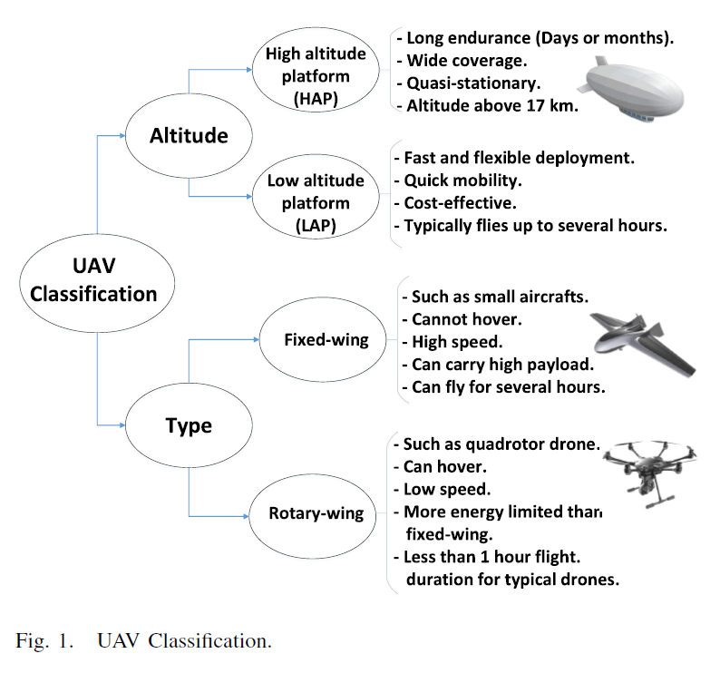

**3] UAV Regulations :**

→ In general, five main criteria are often considered while developing UAVs

1] Applicability 2] Operational limitations 3] Administrative procedures

4] Technical requirement 5] Implementation of ethical constraints

**Applications of Wireless Communication with UAVs:**

**1) UAV Aerial Base Station :**

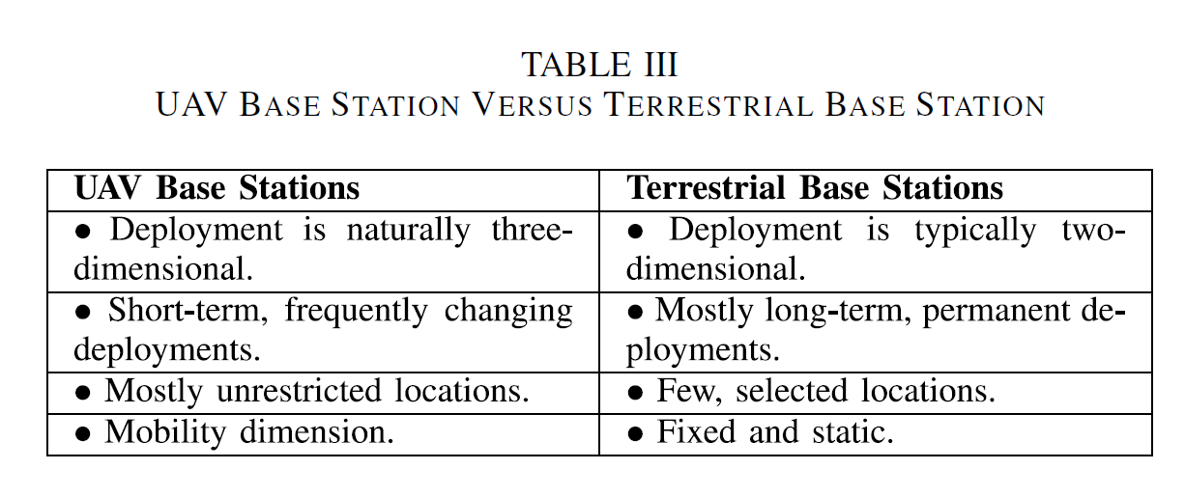

1. *Coverage and Capacity Enhancement of Beyond 5G Wireless Cellular Networks-*  The use of UAV-mounted aerial base stations in 5G networks to address the challenges faced by existing wireless cellular networks. The use of UAV base stations can complement ultra-dense small cell networks and provide a cost-effective approach for providing wireless connectivity to areas with limited infrastructure. Additionally, UAVs can establish LoS communication links to users, potentially providing high-capacity wireless transmission and assisting various terrestrial networks such as D2D and V2V communications.
2. *UAVs as Flying Base Stations for Public Safety Scenarios:* The potential use of UAVs as flying base stations for public safety scenarios, particularly during natural disasters when terrestrial communication networks (floods, earthquakes etc) can be damaged or destroyed. The existing communication technologies may not provide flexibility, low-latency services, and swift adaptation to the environment during such scenarios. UAV-based aerial networks offer a promising solution to provide fast, flexible, and reliable wireless communications as they can easily fly and dynamically change their positions to provide on-demand communications to ground users in emergency situations. UAVs can be deployed as mobile aerial base stations to deliver broadband connectivity to areas with damaged terrestrial wireless infrastructure.
3. *UAV-Assisted Terrestrial Networks for Information Dissemination:*

UAVs can be used to assist terrestrial networks in information dissemination and connectivity enhancement. UAVs can act as flying base stations to support D2D networks, mobile ad-hoc networks, and vehicular networks. By intelligently broadcasting common files among ground devices, drones can facilitate rapid information dissemination and enhance reliability and connectivity. UAV-assisted clustering of ground users can significantly improve the connectivity of terrestrial networks.

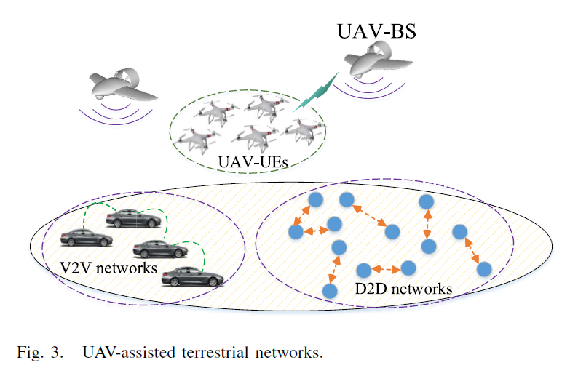

1. *UAVs for IoT Communications:*

Traditional wireless networks are not sufficient to handle the massive IoT environment, and using mobile UAVs as flying base stations is a promising solution. UAVs can be effectively placed to reduce signal attenuation and shadowing effects and enable battery-limited IoT devices to transmit their data with lower power. Additionally, UAVs can serve massive IoT systems by dynamically updating their locations based on the activation pattern of IoT devices. Overall, UAVs can significantly improve the connectivity and energy efficiency of IoT networks.

1. *3D MIMO and Millimeter Wave Communications:* UAVs can be used as flying antenna systems and can perform massive MIMO, 3D network MIMO, and mmW communications. 3D beamforming can create separate beams in the three-dimensional space at the same time, reducing inter-cell interference and enabling higher overall system throughput. The use of drone-based wireless antenna arrays can provide unique opportunities for airborne beamforming, and large numbers of small UAVs within an array formation can form any arbitrary shape and effectively perform beamforming. UAVs equipped with mmW capabilities can establish LoS connections to ground users, reducing propagation loss while operating at high frequencies. Finally, swarms of UAVs can create reconfigurable antenna arrays in the sky.

**2) Cellular-Connected Drones as User Equipments:**

It is natural for drones to utilize wireless infrastructure, and they can serve as users of such technology. Specifically, drones can be utilized for various purposes, including package delivery, surveillance, remote sensing, and virtual reality applications. In fact, drones connected to cellular networks will play a crucial role in enabling the IoT. However, there is a need for a reliable wireless communication infrastructure to effectively control the drones' operations while supporting their application services.

**3) Flying Ad-Hoc Networks (FANETs) with UAVs :**

One of the key use cases of UAVs is in flying ad-hoc networks (FANETs) in

which multiple UAVs communicate in an ad-hoc manner. In particular, a

relaying network of UAVs maintains reliable communication links between a

remote transmitters and receivers that cannot directly communicate due to

obstacles or their long separation distance. Compared to a single UAV, a FANET with multiple small UAVs has the advantages of Scalability, Cost and Survilability.

**4) UAVs as Flying Backhaul for Terrestrial Network :**

//Not needed in detail

/*Wired connections can be expensive and infeasible due to geographical

constraints, especially when dealing with ultra dense cellular networks while

wireless backhauling is a viable and cost-effective solution. In this case,

UAVs can play a key role in enabling cost-effective, reliable, and high speed

Wireless backhaul connectivity for ground networks. So, UAVs can be

optimally placed to avoid obstacles and establish LoS and reliable

communication links. Moreover, the use of UAVs with mmW can establish

high data rate wireless backhaul connections that are needed to cope with

high traffic demands in congested areas.*/

**Challenges**

**A. Air-to-Ground Channel Modeling**

Wireless signals transmitted from a UAV to a ground device can be affected by various factors, such as the medium in which they propagate, the type of UAV and ground device, and the elevation angle. Unlike air-to-air communication, A2G links are more prone to signal blockage, and the path loss is dependent on the location and environment of the UAV and ground device. The likelihood of such signal blockage happening is influenced by factors such as building density and height, propagation environment, and the elevation angle between the UAV and the ground device.

**B. Optimal Deployment of UAVs as Flying Base Stations**

The three dimensional deployment of UAVs is one of the key challenges in UAV-based communications.

The average transmit power of devices can be reduced by 78% by optimally deploying the UAVs.

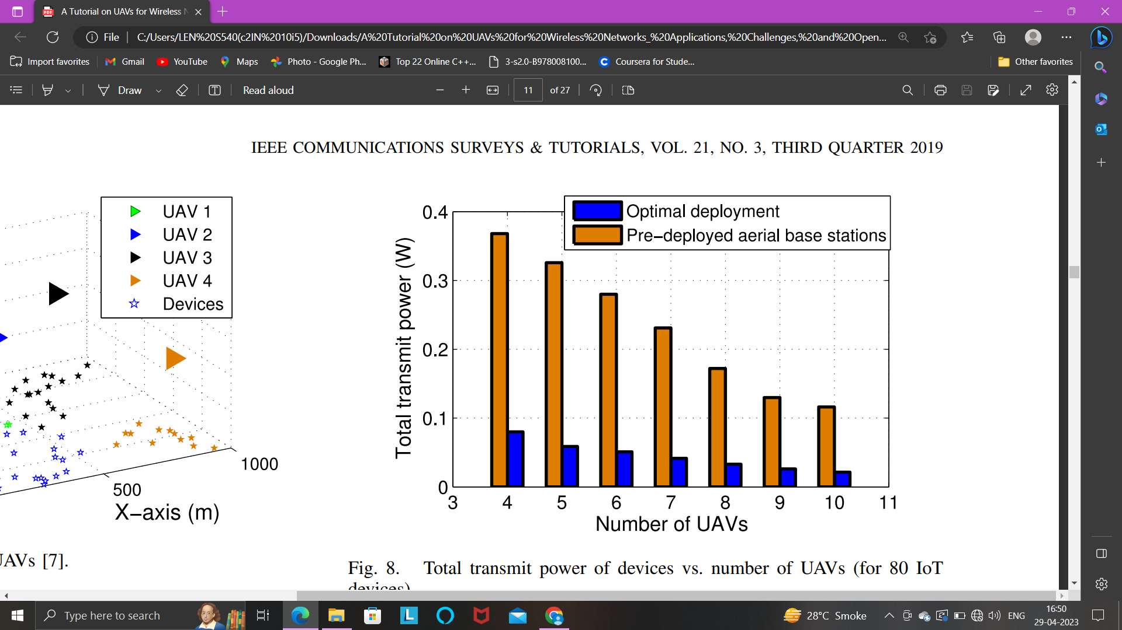

/*When flying at very low altitudes, the likelihood of Line-of-Sight (LoS) connections between the transmitter and receiver decreases due to shadowing effects, resulting in reduced coverage radius. Conversely, at very high altitudes, LoS links are more probable, but the large distance between the transmitter and receiver results in higher path loss and reduced coverage performance. Thus, in order to determine the optimal altitude for UAVs, both the distance and LoS probability should be considered simultaneously.*/

**C. Trajectory Optimization**

A comparison was made between the performance of optimal path planning and a scenario where drones follow pre-defined paths with regard to energy consumption. Results indicated that utilizing optimal path planning led to a reduction of 74% in average total energy consumption when compared to the non-optimal case.

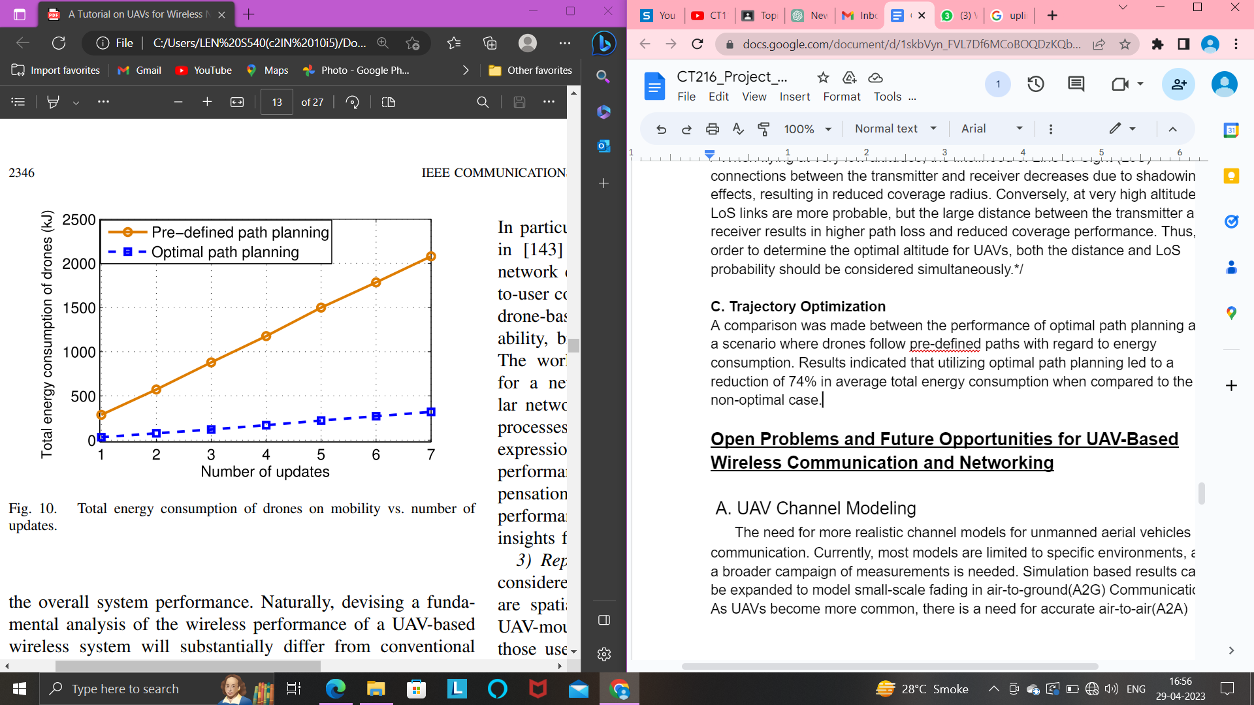

Factors determining UAV’s trajectory:

* QoS requirements of the users
* the energy consumption of the UAV
* kind of the UAV, and the types
* locations of environmental obstacles

**D. Performance Analysis of UAV-Enabled Wireless Networks**

To understand the important trade-offs in designing a wireless network with the help of UAVs, it is essential to evaluate its performance. Short flight duration is a major factor impacting the performance.

The performance of UAV-based communication systems can be measured using various metrics:

* area spectral efficiency
* coverage probability
* Reliability
* latency.

These metrics can be attributed to specific parameters of the UAV such as its altitude, hover time, and trajectory.

**E. Cellular Network Planning and Provisioning With UAVs**

Efficient network planning in UAV-assisted wireless networks involves addressing challenges related to the deployment of aerial and terrestrial base stations, interference management, frequency planning, and user association.

The goal of network planning is to optimize the overall performance of the UAV system, with a focus on maximizing coverage, capacity, and operational cost efficiency.

**F. Resource Management and Energy Efficiency**

Given drones' limited on-board energy, the energy efficiency aspects of drone-based communication systems must be carefully considered. The performance of drone-enabled wireless networks will be severely impacted by the flight time and transmit power restrictions of drones. The development of energy-efficient deployment, path planning, and drone communication solutions can reduce the energy consumption of a drone.

The total energy consumption of a UAV is composed of two main components:

1) Communication related energy

2) Propulsion energy

**G. Drone-UEs in Wireless Networks**

Using flying UAV-UEs in a cellular-connected UAV scenario poses several challenges that need to be addressed. The traditional cellular network, which is primarily designed to serve ground users, may not be equipped to effectively provide connectivity and low-latency requirements for UAV-UEs. Therefore, there is a need for designing an efficient cellular connected UAV system that can support reliable and low-latency communication requirements, mobility and handover management, and seamless connectivity for flying UAV-UEs.

**Open Problems and Future Opportunities for UAV-Based Wireless Communication and Networking**

A. UAV Channel Modeling

The need for more realistic channel models for unmanned aerial vehicles communication. Currently, most models are limited to specific environments, and a broader campaign of measurements is needed. Simulation based results can be expanded to model small-scale fading in air-to-ground(A2G) Communication. As UAVs become more common, there is a need for accurate air-to-air(A2A) channel models that capture that time variation of the channel and Doppler effect due to UAV mobility. Additionally, multipath fading in A2A communications needs to be characterized while considering UAVs’ altitude and antenna movement. Developing accurate channel models will be critical for designing efficient and reliable communication systems for UAVs.

B. UAV Deployment

Some of the open problems for UAV deployment include finding optimal 3D placement of UAVs in the presence of terrestrial networks, such as how to deploy UAVs in coexistence with cellular networks while minimizing mutual interference. Other key open problems include joint optimization of deployment and bandwidth allocation for low-latency communications, joint optimal 3D placement and cell association for flight time minimization, and obstacle-aware deployment of UAVs for maximizing wireless coverage. These problems require new solutions to account for the unique features of UAVs, and addressing them could greatly enhance the efficiency and effectiveness of UAV deployment.

1. Joint optimization of deployment and bandwidth allocation for low latency communications:

This open problem focuses on optimizing the placement and bandwidth allocation of drone-BSs to minimize the maximum transmission latency of users served by these drone-BSs. Given the number of drone-BSs, locations of users, and total bandwidth available, the problem aims to find the optimal location of each drone-BS and its transmission bandwidth to minimize the maximum downlink transmission latency of users. In other words, the goal is to ensure low latency communication for all users by optimizing the deployment and bandwidth allocation of drone-BSs.

1. Joint optimal 3D placement and cell association for flight time minimization:

This open problem refers to finding the optimal 3D placement and association of drone-BSs with ground users in order to minimize the total flight time of the drone-BSs needed to provide wireless services to the users. The flight time depends on various factors such as the number of users connected to the drone-BS, the load on the drone-BS, and the downlink transmission rate. Given the number of drone-BSs, the problem involves jointly optimizing the 3D locations of the drone-BSs and their association with ground users.

1. Obstacle aware deployment of UAVs for maximizing wireless coverage:

The third open problem for UAV deployment is obstacle aware deployment for maximizing wireless coverage. This involves determining the optimal placement of drone-BSs to maximize the coverage areas of ground users while taking into account obstacles such as buildings and terrain. By considering the locations of ground users and obstacles, the 3D positions of drone-BSs can be optimized to ensure that the maximum number of users are covered. This is especially important when the drones operate at high frequency bands such as millimeter wave frequencies, where the coverage performance is highly affected by obstacles. Solving this open problem can significantly improve the efficiency and effectiveness of wireless communication services provided by UAVs.

C. UAV Trajectory Optimization

->UAV trajectory optimization based on the mobility patterns of ground users for maximizing the coverage performance: This involves optimizing the trajectory of UAVs based on the movement patterns of ground users to ensure maximum coverage and improved performance.

- >Obstacle aware trajectory optimization of UAVs considering users’ delay constraints and UAVs’ energy consumption: In this problem, UAV trajectory optimization must take into account the presence of obstacles and also consider the energy consumption and delay constraints of ground users to ensure efficient and effective communication.

- > Trajectory optimization for maximizing reliability and minimizing latency in UAV-enabled wireless networks: This involves optimizing UAV trajectories to ensure reliable communication and minimize latency in UAV-enabled wireless networks.

- >Joint control, communication, and trajectory optimization of UAVs for flight time minimization: This problem involves jointly optimizing control, communication, and trajectory of UAVs to minimize flight time while ensuring efficient and effective communication.

->Optimizing trajectory while minimizing interference to the ground users and being cognizant of the downtilt of the antennas of the ground base stations for cellular-connected UAV-UEs: This problem involves optimizing the trajectory of cellular-connected UAVs while ensuring minimal interference to ground users and taking into account the downtilt of the antennas of the ground base stations.

D). Performance Analysis

->Characterizing the performance of UAV-enabled wireless networks: There is a need to develop tractable expressions for coverage probability and spectral efficiency in heterogeneous aerial-terrestrial networks.

->Tradeoff between spectral efficiency and energy efficiency: Fundamental performance analysis is needed to capture the inherent tradeoffs between spectral efficiency and energy efficiency in UAV networks.

->Incorporating UAV mobility: There is a need to evaluate the performance of UAV-enabled wireless networks while accounting for the mobility of UAVs. This involves capturing the spatial and temporal variations of various performance metrics in the network.

->The trajectory of UAVs affects the quality of wireless links, which in turn affects throughput, latency, and energy efficiency.

E). Planning Cellular Networks with UAVs

->Determining the minimum number of UAVs needed to provide full coverage for a given area that is only partially covered by ground base stations, especially when the area is irregularly shaped.

->Backhaul-aware deployment of UAVs as aerial base stations, taking into account both the backhaul connectivity of the UAVs and the quality-of-service of their users.

->Efficient frequency planning when both ground and aerial base stations and users exist in the network.

->Developing new approaches to dynamically provision UAVs as they join the network.

->Designing robust and adaptive network planning techniques that can account for highly mobile drone-UEs.

->Analyzing the signaling overhead associated with the deployment of both UAV-BSs and UAV-UEs, and how this overhead can affect network performance.

F). Resource Management in UAV Networks

->Dynamic resource management is essential to efficiently allocate bandwidth, energy, transmit power, UAV flight time, and number of UAVs in UAV-based communication systems.

->Adaptive adjustments to the transmit power and trajectory of a flying UAV is a key problem to be solved.

->Optimal bandwidth allocation mechanisms must be designed to capture the impact of UAVs’ locations, mobility, line-of-sight interference, and traffic distribution of ground users.

->Efficient scheduling techniques are necessary to mitigate interference between aerial and terrestrial base stations in a UAV-assisted cellular network.

->Dynamic spectrum sharing in a heterogeneous network of both flying and ground base stations must be analyzed.

->Adopting suitable frequency bands (e.g., WiFi, LTE bands) for UAV operations is an important design problem.

G). Drone-UEs Scenarios

->Robust interference mitigation techniques for massive drone-UEs deployment scenarios.

->Dynamic handover mechanisms to manage frequent handovers due to mobility.

->Accurate ground-to-air channel models for BSs-to-drone communications.

->New scheduling schemes while considering battery limitations of drones.

->Effective solutions that allow meeting URLLC requirements for drone-UEs.

->Analysis of application-specific quality-of-service measures.

H). Lessons Learned

->UAV networks exist in various areas such as comprehensive channel model for UAV communications, energy-aware deployment, analysis of signaling and overhead, reliable communications with path planning, low latency control, inter

ference and handover management. */

1) Introduction

→ Technical solutions have been developed in 4G LTE to handle a limited number of connected UAVs, but this will not be sufficient as the number of UAVs increases.

→ The wireless research community recognizes the importance of aerial communications and is working to develop native and long-lasting support for UAVs in 5G NR and future wireless technologies.

2) UAV Use cases, Systems, and Requirements in 5G NR

→ 5G NR networks might have to meet the above requirements for a large number of connected UAVs.

→ The traditionally ground-focused wireless cellular ecosystem is increasingly concerned with accommodating flying users.

→ The 3GPP has identified the most demanding UAV use cases that could be enabled by 5G cellular support, classified into C2 links and payload data links.

1. UAV UEs with Command and Control Links:

→ The use case involves owners of commercial UAVs using them to deliver mail-ordered goods to their customers' doorsteps. To communicate with the UAV, a controller can be employed, where both the UAV and the controller are 5G-compliant devices.

→ Before the owners can fly their UAV, they need to receive clearance from the UAV traffic management (UTM). Once cleared, the UTM provides a series of waypoints for the UAV to follow while cruising from the warehouse to the recipient.

→ There might be instances where the UAV owner needs to take direct steering control of the UAV. This could be for climbing to cruise altitude, dropping a package at the destination, or observing an accident that has occurred along the way.

→ During direct steering control, the manoeuvring requires UL video feedback from the UAV. The specifications for such feedback depend on whether the controller is in visual line-of-sight (VLoS) or beyond VLoS (BVLoS).

→ Autonomous flight is also possible via the UTM, which provides predefined trajectories in the form of four-dimensional polygons. The UAV feeds back periodic position reports for tracking purposes.

1. UAV UEs with Data Payloads

→ UAVs can be used to provide users with an immersive experience of virtual reality through panoramic 8K video live broadcast, captured by a 360◦ spherical view camera on board the UAV and uploaded in real-time to a cloud server.

→ This use case requires high data rates, low latency, and accurate positioning to avoid potential damage to life or property in densely populated areas.

→ Traditional satellite-based positioning methods may not be sufficient in areas with many buildings, so UAVs may employ 4×4K AI surveillance, sending four-way 4K full-angle camera data to an AI controller that issues timely control instructions to ensure safety.

→ Laser mapping, high-definition (HD) patrol, and remote UAV control through HD video are other applications with similar requirements identified by the 3GPP.

3) UAV UEs With Direct Device-to-Device (D2D) Capabilities:

Sure, here are the explanations point-wise:

→ D2D enables direct communication between devices in close proximity, without the need for a ground BS. This makes it useful in situations where cellular coverage is not available, such as in remote areas or during disasters.

→ In the case of UAV swarm deployments, D2D can be used to enable continuous coordination between UAVs, allowing them to share information and work together to complete their tasks.

→ Autonomous UAVs also require D2D communication to self-control aerial traffic and avoid collisions. This is particularly important in scenarios where multiple UAVs are flying in the same area and need to maintain safe distances from each other.

→ D2D communication can also be used to share sensor data between UAVs, enabling them to gather more accurate and comprehensive information about their surroundings.

→ Overall, D2D can help improve the efficiency and safety of UAV operations by enabling direct communication and coordination between UAVs, even in situations where cellular coverage is limited or unavailable.

4) UAV BSs With Relaying Capabilities:

→ In scenarios such as disaster monitoring, border surveillance, and emergency assistance, UAVs carrying a BS, known as UxNB, can be deployed quickly.

→ UxNBs are useful in coverage of hot-spot events where there is a sudden surge in broadband demand.

→ The specifications for this use case have not yet been defined by 3GPP, but it is expected that stringent command and control (C2) as well as payload data requirements will be needed.

→ UxNBs will be autonomously controlled and dispatched as the network sees fit.

→ The required backhaul bit rates for each UAV radio access node could be up to several Gbps depending on the traffic load that each UxNB has to handle.

3) NR Features in Support of UAVs

→ Massive MIMO and mmWave: Massive MIMO refers to the use of large antenna arrays within sub-6 GHz base stations (BSs) for beamforming and spatial multiplexing. At the same time, mmWave provides wideband transmissions above 24.25 GHz, allowing high-data-rate applications to operate with massive bandwidths. These features allow for the use of multiple users on each time-frequency resource, which is particularly useful for UAVs.

→ LTE/NR Dual Connectivity: This feature allows LTE and NR to coexist in the same geographical areas. By providing information redundancy over both links, dual-connected UAVs can enjoy more reliable communication than their single-connected counterparts. Furthermore, UAV broadband UL traffic offloading can be achieved, and UAVs can take advantage of the fact that they are immune to one of the typical issues faced by ground UE's, insufficient UL transmit power.

→ Ultra-Lean Design: NR has been designed to reduce the number of always-on transmissions to minimize interference and free up network resources. This design is particularly useful for efficient aerial communications, as only a subset of NR BSs can transmit towards UAVs in a dedicated part of the spectrum.

Overall, these features help to satisfy UAV connectivity requirements, such as high throughput, low latency, reliability, and energy efficiency.

4) The 6G Vision

→ The article discusses the potential implications and opportunities that may arise with the advent of 6G connectivity. It suggests that autonomous cars-as-a-service and air taxis will redefine how we commute, and may eventually lead to fully driverless cars hitting the road. This will shift mainstream production from Level 2 to Level 5 automation, with vehicles being able to go anywhere and anytime without human intervention.

→ The article also mentions the potential for electric vertical takeoff and landing vehicles (eVTOLs) to reduce congestion in megalopolis and curb energy consumption. Although there are hurdles like safety regulations, noise concerns, and infrastructure needs that could prolong projected launch dates, over 100 cities are already targeting urban air mobility solutions. Several companies are planning to lift air taxis, and the market for it is expected to be worth $1.5 trillion by 2040.

→ The article also discusses Chinese drone company EHang's recent success in flying its two-seater passenger-grade autonomous UAV over a densely populated downtown area in Korea. This is seen as a dream of mankind for the future transportation. Meanwhile, Uber Elevate seeks to build and scale Uber Air, a multimodal transportation product that seamlessly integrates time-saving first- and last-mile ground transportation.

→ While autonomous air taxis could eventually become one of the defining killer apps of the 6G era, they exhibit unprecedented connectivity requirements all around a 3D environment. Accurate cm-grade 3D localization and navigation will also be essential at heights ranging from tens to hundreds of meters. 6G development towards even higher frequency ranges, wider bandwidths, and massive antenna arrays will enable sensing solutions with very fine range, Doppler, and angular resolutions. Improved positioning may also be achieved by using new reference nodes, such as the rooftop-mounted BSs and satellites or high-altitude platforms (HAPs), which may serve as aerial radio access nodes in 6G cellular networks.

→ Besides supporting autonomous eVTOLs, future networks are meant to provide reliable, seamless, robust, and high-speed data connectivity for eVTOL passengers, enhancing their flight experience. Mobile operator Ooredoo recently connected a two-passenger, driverless air taxi to its 5G network, achieving rates up to 2.6 Gbps. However, many more air taxis with a plurality of flying passengers are expected to travel at hundreds of meters above ground, and next-generation mobile networks must be designed and planned appropriately.